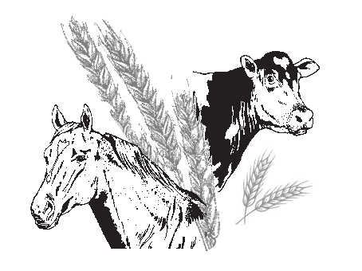**Toogoolawah Dairying Agricultural & Industrial Association Inc.**

**ABN 95 356 680 328**

P.O. Box 219 President: Vern Doyle 0419 706 617

Toogoolawah Q 4313 Secretary: Jonella Dargusch 0417 738 590

EMAIL: [toogoolawahshow@gmail.com](mailto:toogoolawahshow@gmail.com) Treasurer: Lois Lindsay 019 199 729

**2 DAY SHOW PASS FORM**

7th & 8th June 2024

**Name/s:**

|  |  |
| --- | --- |
| 1. |  |
| 2. |  |
| 3. |  |
| 4. |  |
| 5. |  |
| 6. |  |

**Postal Address**

|  |  |
| --- | --- |
|  | |
|  | **Post Code:** |

**Telephone:**

|  |  |
| --- | --- |
| **Home:** | **Mobile:** |
| **Email:** | |

Signature: ____________________________________Date: ____________________________

I agree to accept email Notifications from Committee: Yes No

Fee: $20.00 per person

*2 day Pass entitled to unlimited admission during Show Time*

Cash EFT Cheque

**Please make Cheque payable to:** Toogoolawah Dairying Agricultural & Industrial Association Inc

**Bank Details:** BSB: 014 619 Acc: 1110 14122 Ref: Surname

**Return form** via email or post to address above. For more information, 0417 738 590